**B.Tech Capstone Project Synopsis 2021-22**

1. **Project Title:**

**“Novel non-invasive detection of hemoglobin level using deep learning algorithms”**

Group 1 - AI, ML, DL, Data Science

Group 4 - Computer Vision, Embedded Systems, IoT

The application domains to be focused on are:

Healthcare

**2. In-house project**

**3. Team Member Names:**

1. Atharva Belamkar
2. Tushar Birari
3. Akhil Bannur
4. Sanskar Sharma

**4. Project Description:**

This project aims to detect hemoglobin levels using a non-invasive method by capturing images of the palpebral conjunctiva and analyzing them using deep learning algorithms. This project also aims to create a unified dataset of pictures of the palpebral conjunctiva of patients based in India, along with their hemoglobin values.

**5. Literature Survey:**

1. G. Dimauro, A. Guarini, D. Caivano, F. Girardi, C. Pasciolla and A. Iacobazzi, "Detecting Clinical Signs of Anaemia From Digital Images of the Palpebral Conjunctiva," in *IEEE Access*, vol. 7, pp. 113488-113498, 2019, doi: 10.1109/ACCESS.2019.2932274.

<https://ieeexplore.ieee.org/document/8782533>

1. A. Tamir *et al*., "Detection of anemia from image of the anterior conjunctiva of the eye by image processing and thresholding," *2017 IEEE Region 10 Humanitarian Technology Conference (R10-HTC)*, 2017, pp. 697-701, doi: 10.1109/R10-HTC.2017.8289053.

<https://ieeexplore.ieee.org/document/8289053>

1. Selim Suner, Gregory Crawford, John McMurdy, Gregory Jay,

Non-Invasive Determination of Hemoglobin by Digital Photography of Palpebral Conjunctiva,

The Journal of Emergency Medicine,Volume 33, Issue 2,2007, Pages 105-111, ISSN 0736-4679

<https://www.sciencedirect.com/science/article/abs/pii/S0736467907001412>

1. Collings, Shaun, 2015, "Dataset for the detection of anaemia using conjunctival images", Harvard Dataverse, V2

https://dataverse.harvard.edu/dataset.xhtml?persistentId=doi:10.7910/DVN/L4MDKC

1. Edward Jay Wang, William Li, Doug Hawkins, Terry Gernsheimer, Colette Norby-Slycord, and Shwetak N. Patel. 2016. HemaApp: noninvasive blood screening of hemoglobin using smartphone cameras. In Proceedings of the 2016 ACM International Joint Conference on Pervasive and Ubiquitous Computing (UbiComp '16). Association for Computing Machinery, New York, NY, USA, 593–604.

DOI:<https://doi.org/10.1145/2971648.2971653>

1. Yi-Ming Chen, Shaou-Gang Miaou, Hongyu Bian,

Examining palpebral conjunctiva for anemia assessment with image processing methods,

Computer Methods and Programs in Biomedicine, Volume 137,2016,Pages 125-135,ISSN 0169-2607,

https://doi.org/10.1016/j.cmpb.2016.08.025.

(<https://www.sciencedirect.com/science/article/pii/S0169260716302474>)

1. Anggraeni_2017,doi={10.1088/1757-899x/172/1/012030},url= <https://doi.org/10.1088/1757-899x/172/1/012030> ,,year = 2017, month = {feb},publisher = {{IOP} Publishing},volume = {172},pages = {012030},author = {M D Anggraeni and A Fatoni},title = {Non-invasive Self-Care Anemia Detection during Pregnancy Using a Smartphone Camera},Journal = {{IOP} Conference Series: Materials Science and Engineering}
2. Author = {Collings, Shaun and Thompson, Oliver and Hirst, Evan and Goossens, Louise and George, Anup and Weinkove, Robert}, doi = {10.1371/journal.pone.0153286}, journal = {PLOS ONE}, keywords = {}, note = <https://journals.plos.org/plosone/article/file?id=10.1371/journal.pone.0153286&type=printable> number = {4}, pages = {e0153286}, title = {Non-Invasive Detection of Anaemia Using Digital Photographs of the Conjunctiva}, url=<https://app.dimensions.ai/details/publication/pub.1020604454> volume = {11}, year = {2016}

**6. Feasibility Study**

1. The performance of the system was tested either by extracting manually the palpebral conjunctiva from images or by extracting them in a semi-automatic way based on the SLIC Superpixel algorithm. The SMOTE and ROSE algorithms were evaluated to balance the dataset, and some classification algorithms for assessing the anaemic condition were tested.
2. An “erythema index” (EI) has been developed to objectively quantify the degree of erythema of skin lesions, using digital photography followed by analysis of the red and green components of images. A computer program processes the image to extract RGB spectrum of the anterior conjunctival pallor and compares it with a pre-determined threshold value to conclude whether the subject is anemic or not.
3. The procedure for preprocessing a dataset including photos of patients' conjunctiva and extracting the region of interest is described (ROI). Following ROI extraction, new pictures are formed by adding image augmentation to the dataset size and using the suggested model to predict the outcome class, i.e. anaemic or non-anemic.
4. Implement the most basic version of the ANN and SVM.

**7. Literature Survey (Tabular Format):**

Papers are mentioned below

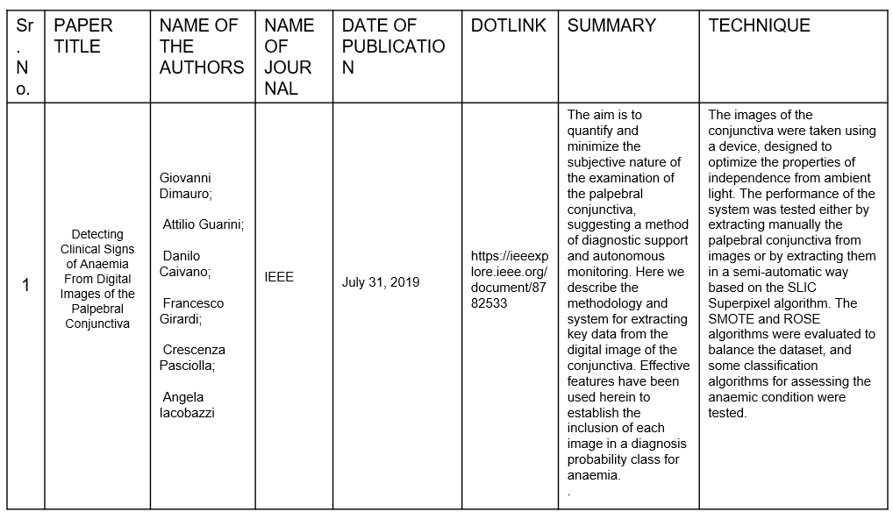

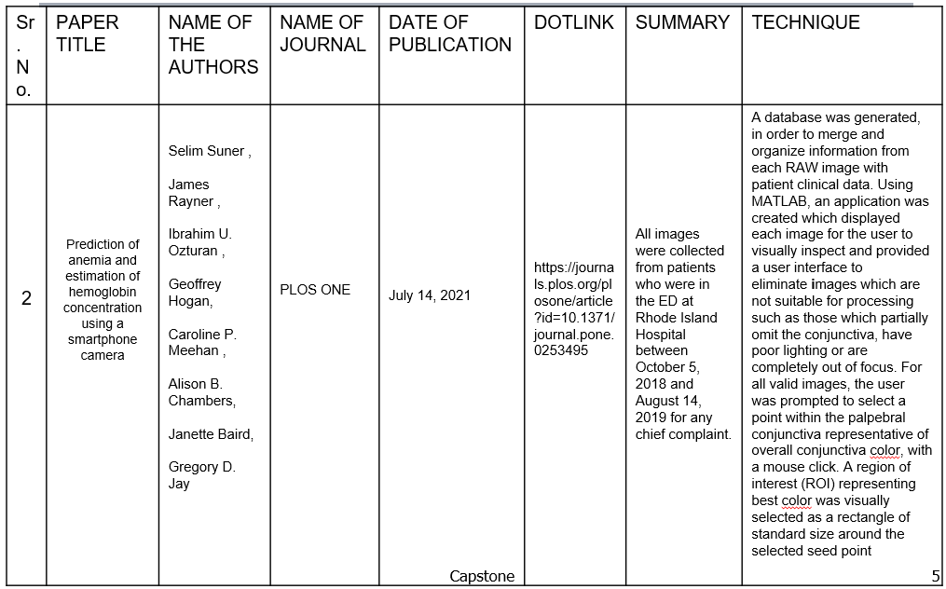

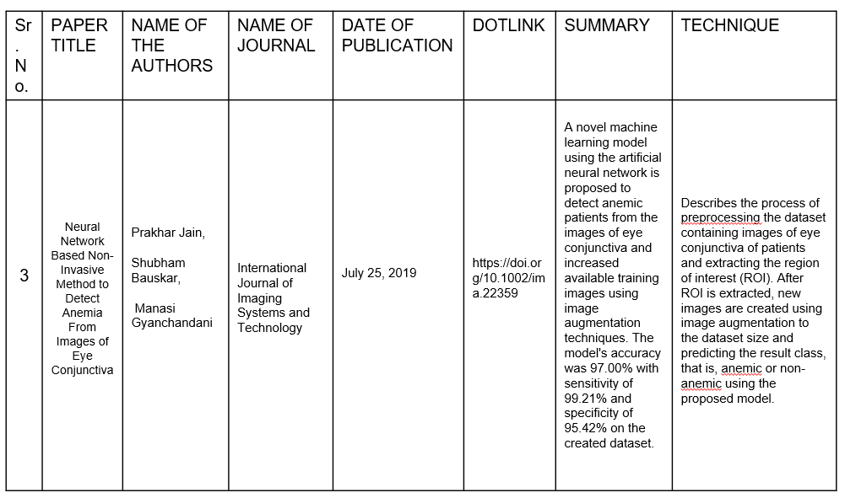

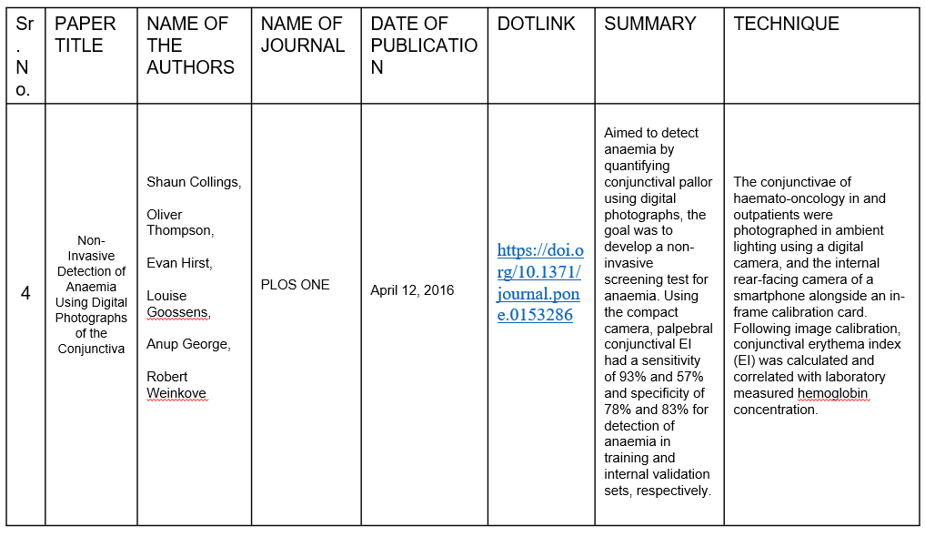

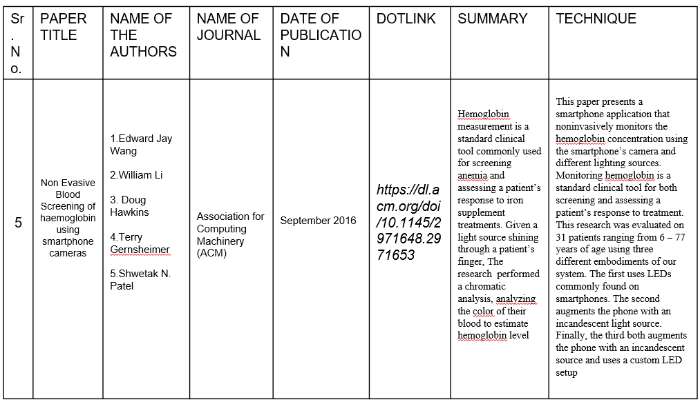

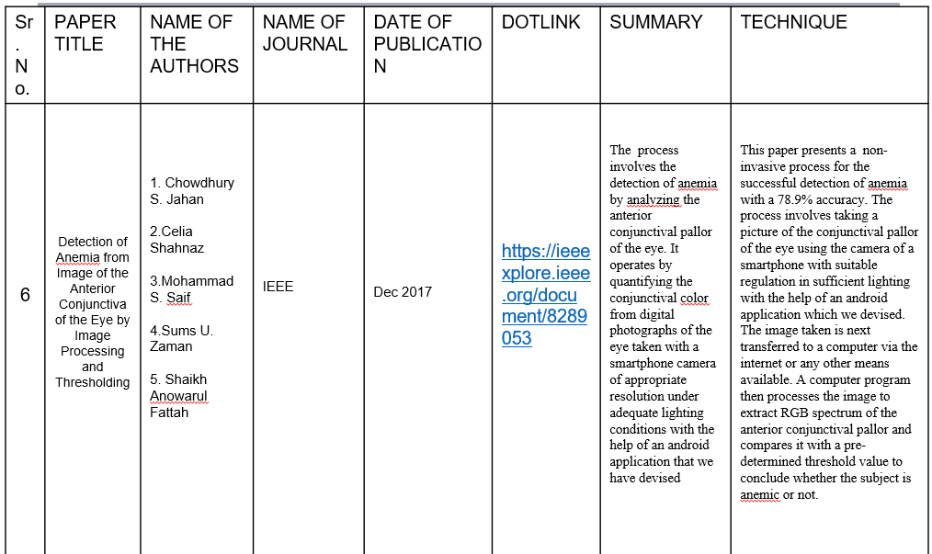

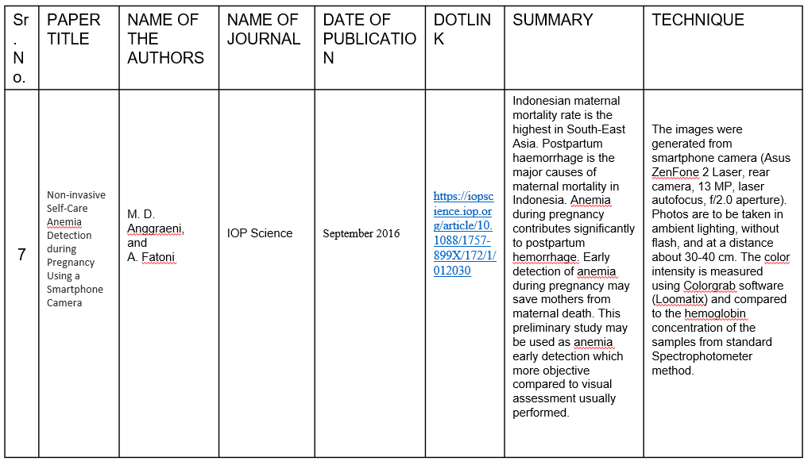

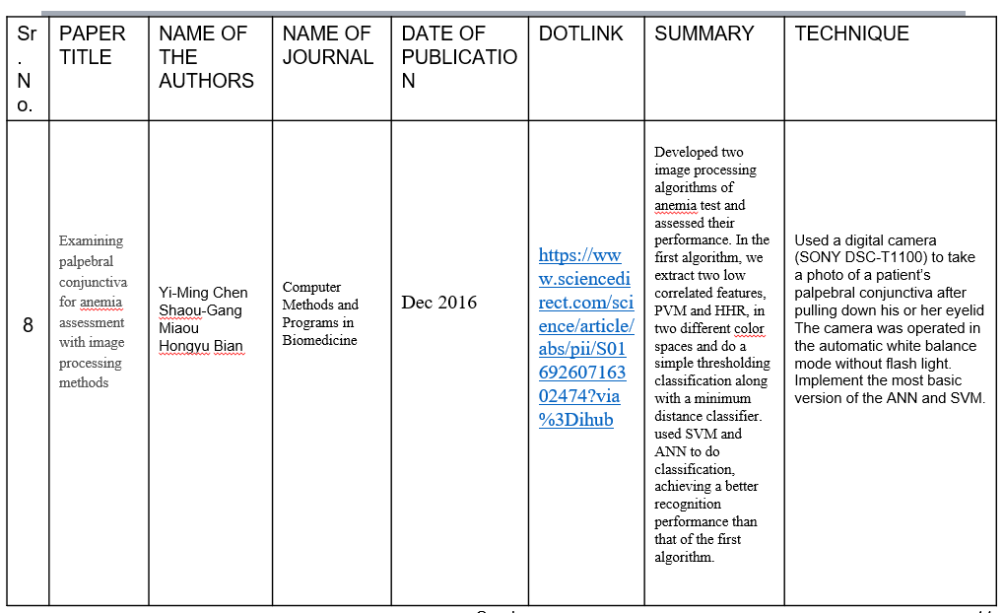

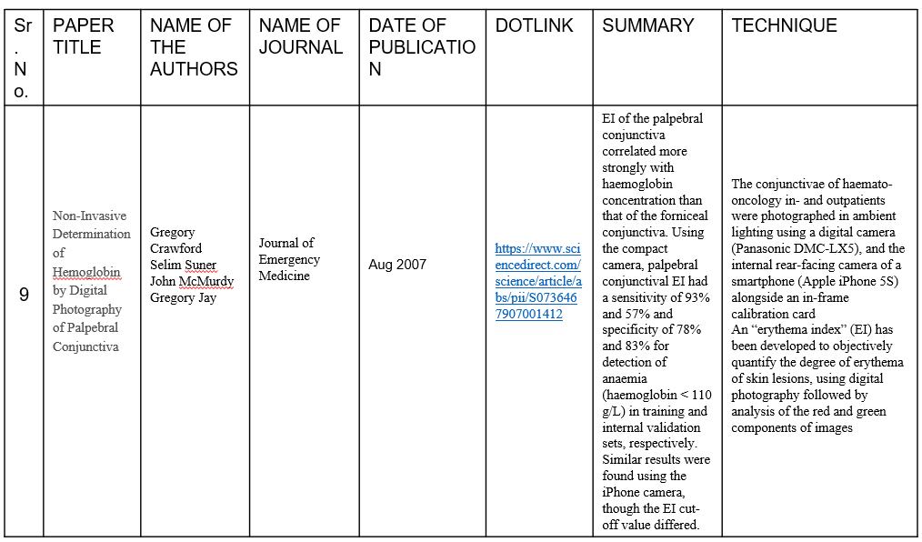

**8. Low level Design:**

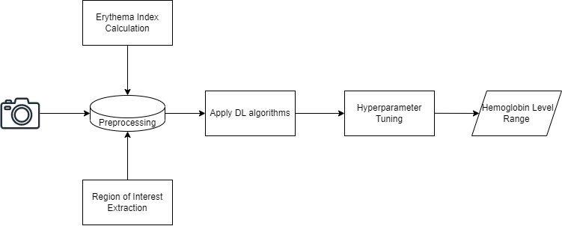

Fig.1 - Low level design

**9. Guide:**

Prof. Shilpa Sonawani